Brian Engel

Module 1 Class Diagram

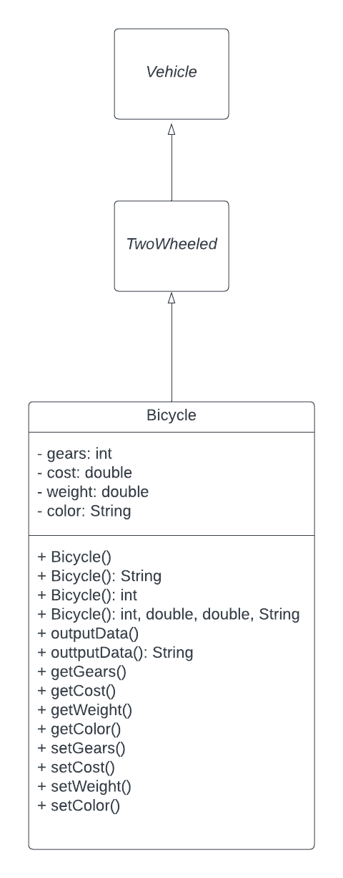

Using classes is an example of portability, keeping the code modular.

TwoWheeled inherits from Vehicle, and Bicycle inherits from TwoWheeled.

Both TwoWheeled and Vehicle are in italics since they are abstract and don’t get instantiated.

Bicycle has 4 private attributes which is encapsulation: gears which is an integer, cost which is a double, weight which is a double, and color which is a string.

Bicycle also has 4 constructor methods: one default, one that takes a string, one that takes an integer, and one that takes an integer, 2 doubles, and a string. Overloading a constructor is used with polymorphism.

Bicycle has 2 public outputData methods: one default, and one that takes a string.

Bicycle also has a public accessor and a public mutator for each of the attributes.